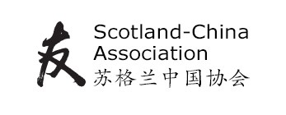
THE SCOTLAND–CHINA ASSOCIATION
2020 Scottish Primary Schools Competition
Design a kite
Entry form
School: ………………………………………………………………………………………………………………
Address: …………………………………………………………………………………………………………….
………………………………………………………………………………………………………………...
Post code: ………………………………………………..
Local Authority Area: ………………………………………………………………………………………...
Contact: …………………………………………………………………………………………………………….
Email: ………………………………………………………………………………………………………………..
Number of classes you wish to enter:
P5 ( )
P6 ( )
P7 ( )
Please send entries during the week beginning 11th May, and no later than Friday 15th May, with this completed entry form, to
SCA Schools Competition
Confucius Institute for Scotland
Abden House
1 Marchhall Crescent, Edinburgh EH16 5HP.

